INFLAMMATION
- Inflammation is protective response of vascularized tissue to eliminate microbes or toxins from the site of cell damage or sites of infection
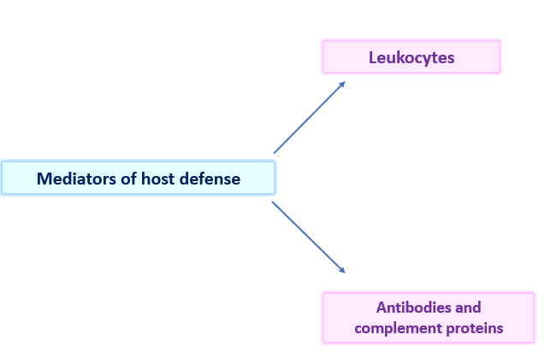
HISTORICAL EVENTS
- Inflammation was first described by Egyptian papyrus (around 3000BC)
- Later Roman writer, Celsus (1st century AD) first listed 4 cardinal signs of inflammation
- Rudolf Virchow added “loss of function (function laesa) in the 19th century
- John Hunter ( Scottish surgeon) – inflammation is not a disease but a stereotypic response to injurious stimuli by host
- Elie Metchnikoff - described phagocytosis
CAUSES OF INFLAMMATION
- Infections – bacterial, viral, fungal, parasitic and microbial toxins
- Necrotic tissue – molecules released from necrotic cells induce inflammatory reaction
- Foreign bodies (splinters, dirt, sutures) – elicit inflammation by themselves or can cause tissue injury . Deposition of endogenous substances like urate crystals, cholesterol crystals, lipids can also produce inflammation
- Immune reactions – autoimmune diseases where injurious immune responses are directed against self antigens

STEPS IN INFLAMMATORY REACTION
- RECOGNITION OF NOXIOUS AGENTS
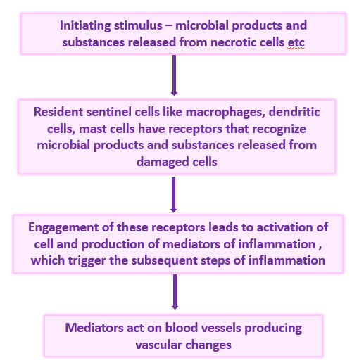
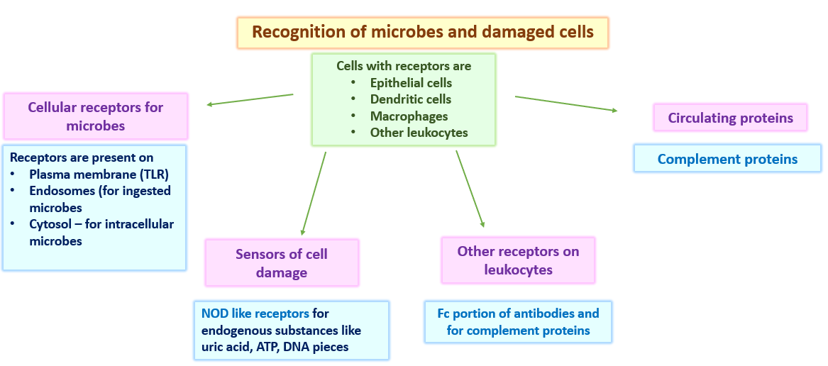
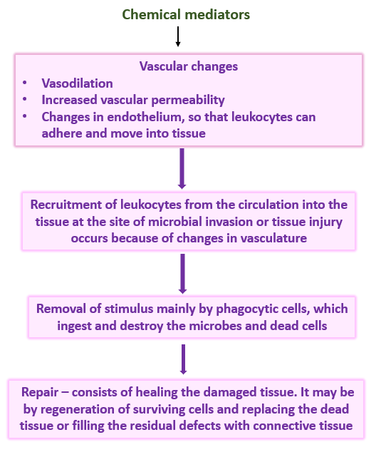
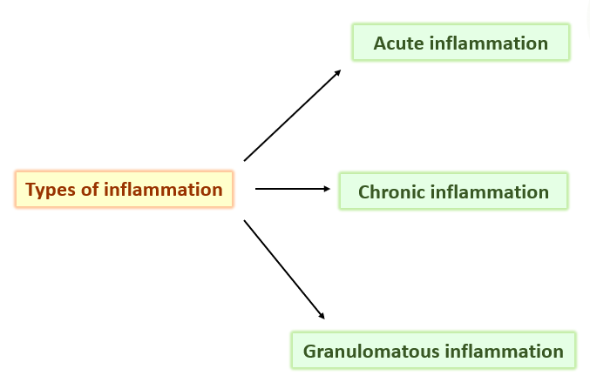
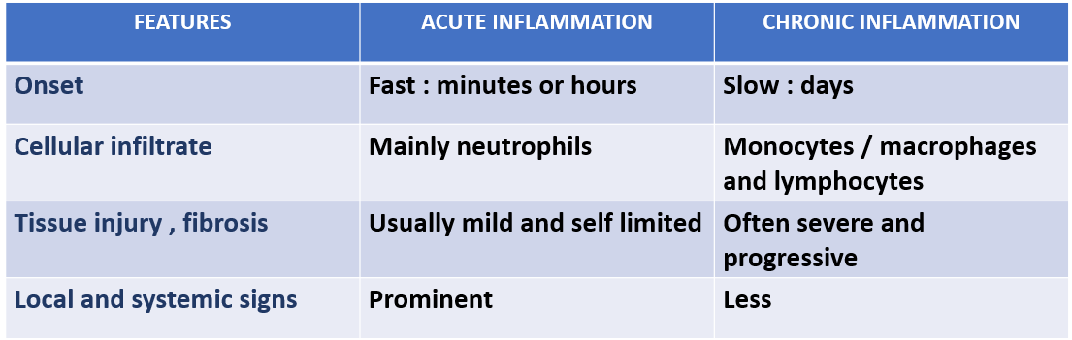
Nature of the leukocyte infiltrate varies with the age of the inflammatory response and the type of stimulus
- Neutrophils respond faster to chemokines and are more in number
- Neutrophils are short lived and undergo apoptosis
- Monocytes survive longer and proliferate in tissues
- Once leukocytes are recruited, they must be activated to perform their functionsSS
- Responses of leukocytes depend upon the receptors which deliver the signals to leukocytes
