ACUTE INFLAMMATION
Definition
- Acute inflammation is rapid response to injurious agent that serves to deliver mediators of host defense to the site of injury to eliminate the injurious agent
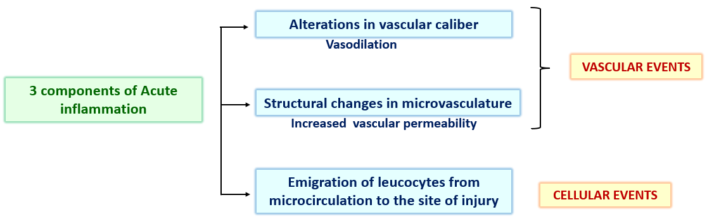

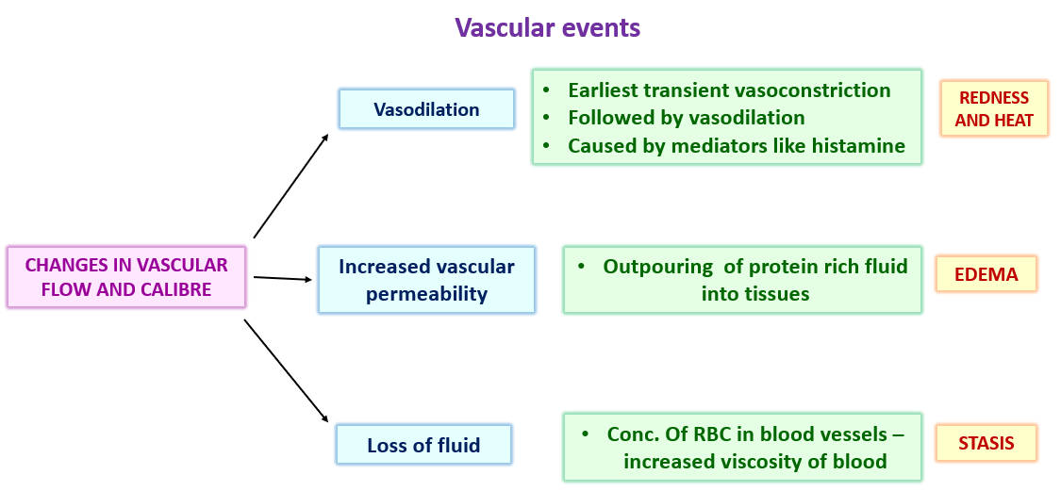

Causes of increased vascular permeability (vascular leakage)
- Formation of endothelial gaps in venules
  - Mediated by histamine, bradykinin and leukotrienes
  - Contraction of endothelial cells creates gap
  - Fast & short lived commonly effecting veinules

- Direct injury to endothelial cells
  - By Microbial toxins , burns, irradiation & chemicals
  - Arterioles , capillaries & veinules
  - Vascular leakage begins after 2 to 12 hours and may last for even days

- Leucocyte – dependent injury
  - Mostly venules , pulmonary capillaries & glomerular capillaries
  - Late response & long lived (hours)
  - Early stage leucocyte adhere to endothelium – activated – release toxic oxygen species & proteolytic enzymes – endothelial injury & detachment – increased permeability

- Increased transcytosis
  - occurs across the channels consisting of clusters of interconnected & uncoated vesicles & vacuoles called vesicovacuolar organelles which are located near intercellular junctions
  - VEGF – causes increasing the number & size of these channels

- Leakage from new blood vessels
  - New blood vessels formed are leaky until endothelial cells mature
  - Factors causing angiogenesis also increase the vascular permeability

Cellular events – leukocyte extravasation & phagocytosis
- Sequence of events in the extravasation of leucocytes
- In the lumen – margination , rolling & adhesion to endothelium
- Diapedesis - transmigration across the endothelium
- Chemotaxis - Migration in the interstitial tissue towards chemotactic agent
- Mediated by chemical mediators which act as chemoattractants and modulate the surface expression of adhesion molecules on leukocytes and endothelial cells

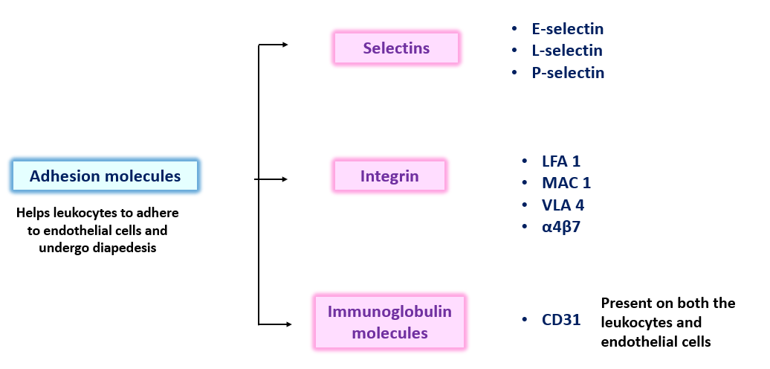

SELECTINS
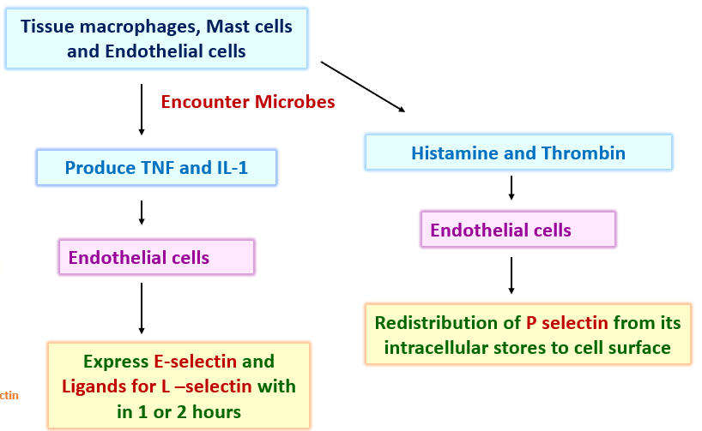
Selectins – Initial rolling and interaction is mediated by selectins
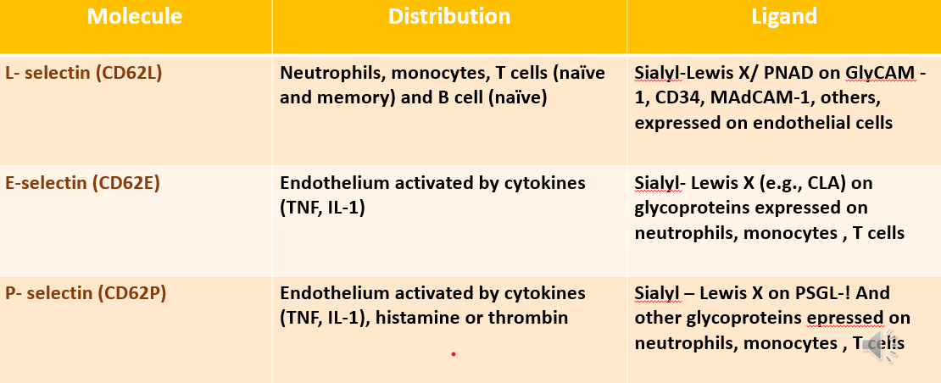

INTEGRINS
- These are heterodimeric leukocyte proteins which causes firm adhesion of leukocytes to endothelial cells
- These proteins promote cell-cell & cell- matrix interactions
- They integrate signals from extra cellular ligand with cytoskeleton dependent motility , shape change & phagocytic responses
Leucocyte adhesion & transmigration
- Rolling –
  - L-selectins present on the leukocytes will bind with ligands for L-selectin on endothelial cells.
  - E-selectins present on the endothelial cells and bind with ligands on leukocytes
  - This leads to loose adhesion and rolling of leukocytes on endothelial cells
- Integrin activation by chemokines
  - Chemokines produced by macrophages at the site of injurious stimuli binds to the proteoglycans present on the endothelial surface
  - When the leukocytes rolling on the surface comes in contact with chemokines, low affinity integrins present on leukocytes are converted into high affinity integrins which bind firmly to the ligands on the surface of the endothelial surface

Integrins | Distribution | Ligands
LFA 1 (CD11aCD18)  Lymphocyte function Associated antigen-1 | Neutrophils, monocytes, T cells | ICAM -1 (CD54)  (Intercellular adhesion molecule-1)
MAC-1 (CD11bCD18)  (Macrophage 1 antigen) | Monocytes and Dendritic cells | ICAM -2 (CD102)  (Intercellular adhesion molecule-2)
α4β7 (CD49dCD29) | Monocytes and T cells | MAdCAM -1  (Mucosal vascular Addressin Cell Adhesion Molecule -1)
VLA 4 (CD49aCD29)  (Very late antIgen -4) | Monocytes and T cells | VCAM 1 (CD106)  (Vascular cell adhesion molecule-1)

Leucocyte migration through adhesion – diapedesis
- Leukocyte recruitment by migration of the leukocytes through intact endothelium, is called transmigration or diapedesis
- Transmigration of leukocytes occurs mainly in postcapillary venules
- Chemokines act on the adherent leukocytes and stimulate the cells to migrate through inter endothelial gaps toward the chemical concentration gradient, that is, toward the site of injury or infection where the chemokines are being produced
- Adhesion molecules present in the intercellular junctions between endothelial cells e.g. member of the immunoglobulin superfamily called CD31 or PECAM-1 (platelet endothelial cell adhesion molecule) are involved in Transmigration of leukocytes.
- After traversing the endothelium, leukocytes pierce the basement membrane by secreting collagenases, and enter the extravascular space
- After leukocytes pass through, the basement membranes become continuous again
Chemotaxis
Definition - Locomotion oriented along the chemical gradient
Chemo attractants
They can be -
Exogenous – Bacterial products
Endogenous – a) components of complement system e.g. C5a
b) Products of Lipoxygenase pathway mainly Leukotrienes
c) Cytokines

