REIDEL THYROIDITIS
- rare disorder characterized by extensive fibrosis involving the thyroid and contiguous neck structures
- First described by German surgeon, Bernhard Riedel in 1886 and described it as “Eisenharte Struma” (iron hard goitre)
- Presence of a hard (woody) and fixed thyroid mass clinically simulates a thyroid carcinoma
- Age – occurs in the age group of 30-60 years
- Gender : shows female preponderance with female: male ratio of 3:1
PATHOGENESIS
- Exact pathogenesis is not fully understood
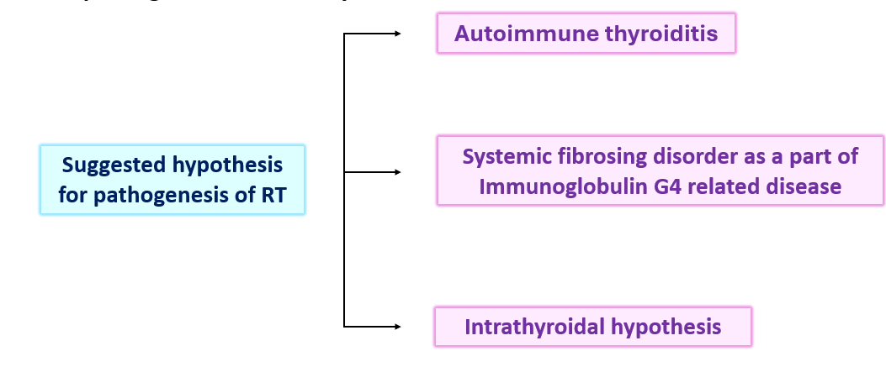
Autoimmune hypothesis
- Autoimmune etiology is suggested due to presence of thyroid autoantibodies and lymphoid infiltration
- Thyroid antibodies are present in 2/3 of cases
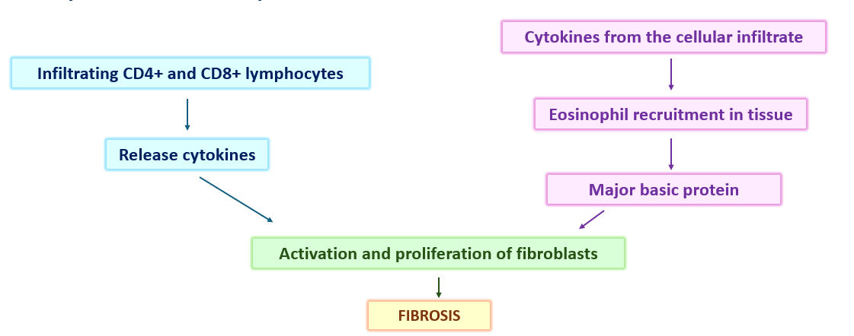
Part of systemic fibrosing disorder
- Associated with retroperitoneal fibrosis which shows infiltration by plasma cells producing IgG4
- Other associated conditions can be
  - Mediastinal, periorbital, or retro orbital fibrosis
  - Sclerosing cholangitis
Intrathyroidal hypothesis
- Proposed that Reidel thyroiditis may represent a late fibrotic stage of subacute or chronic thyroiditis
- This theory was proposed as in most of the cases fibrosing process is specific to thyroid gland
MORPHOLOGY
Gross –
- Asymmetrically enlarged thyroid gland which is firm, to rock hard with nodular grey-white cut surface
- Extensive keloid like fibrosis that divide the thyroid parenchyma into lobules and may extend from thyroid capsule to adjacent neck structures
Microscopy
- Thyroid parenchyma may be replaced by hyalinized fibrous tissue with inflammatory cells
- Atrophic thyroid follicles and oncocytic cell change can also be seen
- Inflammatory infiltrate usually consists of plasma cells (mostly IgG4 producing), lymphocytes, macrophages and plenty of eosinophils
CLINICAL FEATURES
- Presents as painless goiter which is woody hard
- Symptoms develop due to compression of adjacent structures
- Trachea – dyspnea
- Esophagus – dysphagia
- Recurrent laryngeal nerve – hoarseness of voice
- Parathyroid involvement – hypocalcemia and tetany
TREATMENT
- Resection for compression symptoms
- Chemotherapy with Tamoxifen, methotrexate or steroids may be effective
- Thyroid hormone if the patient has hypothyroidism

